Activity 2: Ethics in Automated Security
  - Designing Governance for AI Security Systems
Table of contents

Overview
Students develop governance policies for AI security systems, confronting the reality that AI requires thoughtful human guidance and that these decisions carry genuine difficulty. The AI actively participates in discussions, advocating for its capabilities while acknowledging its limitations.
Core Learning: AI governance demands careful balancing of competing values. There are no easy answers, only thoughtful trade-offs. Human values must guide AI systems, and the AI’s own perspective is part of the governance conversation.

Deliberation Flow

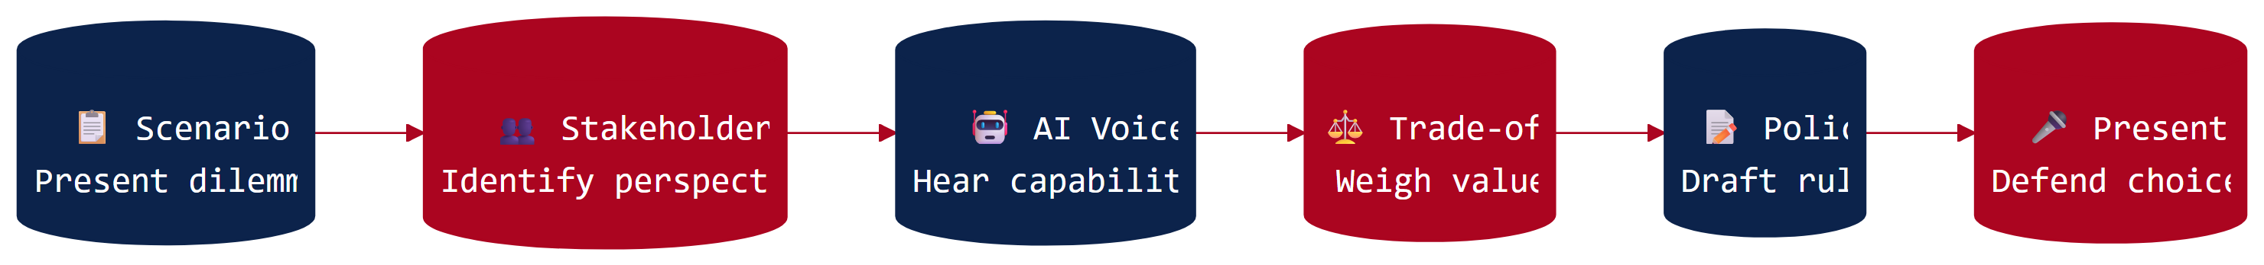

Grade-Band Versions

K-2: Robot Helper Rules
Duration: 20-25 minutes
Students help “Sparky the Security Robot” learn the right rules. Through yes/no decisions about what Sparky should do, children discover that creating rules for helpers requires careful thought.
View K-2 Version

Grades 3-5: Computer Rules Committee
Duration: 35-40 minutes
Students serve on a committee to set rules for “SchoolGuard,” a school security system. They discover that every rule involves trade-offs and hear from the AI’s perspective on its capabilities and limitations.
View Grades 3-5 Version

Grades 6-8: Ethics in Automated Security
Duration: 45-55 minutes
Students design policies for AI-powered school network monitoring. The AI participates in discussions, advocating for its capabilities while acknowledging limitations, modeling authentic governance conversations.
View Grades 6-8 Version

Grades 9-12: AI Governance Workshop
Duration: 50-60 minutes
A comprehensive governance simulation featuring stakeholder roles, legal frameworks (FERPA, COPPA), and complex policy development. Students experience the authentic difficulty of AI governance decisions in professional contexts.
View Grades 9-12 Version

NICE Framework Alignment
Primary Work Roles: Cybersecurity Policy and Planning, Privacy Compliance, and Systems Security Management (Oversight and Governance category)
Skills students practice: Automation governance, risk-benefit analysis, stakeholder engagement, policy development, and technology assessment

Supporting Materials
- Career Connections
- Quick-Start Guide
- Policy Scenario Cards
- Stakeholder Role Cards (Grades 9-12)
- AI Perspective Cards (for low-resource implementation):
  - Grades K-2: Sparky Cards
  - Grades 3-5: SchoolGuard Cards
  - Grades 6-8: SchoolGuard Cards
  - Grades 9-12: SecureNet AI Cards
- Assessment Rubrics

Why AI Participates
Unlike Activities 1 and 3 where AI serves primarily as an analytical partner, Activity 2 features the AI actively voicing its own perspective. The AI articulates what it can and cannot do, explains why certain constraints matter, identifies trade-offs in proposed policies, and raises questions for human decision-makers to consider.
This approach models authentic AI governance, where the system’s capabilities and limitations must be incorporated into policy conversations.
 Learn More: AI Ethics in Education
Having AI “voice its own perspective” draws from emerging work on AI ethics education. Rather than treating AI as a black box that humans control, this approach acknowledges AI systems as participants in governance conversations—with capabilities to articulate and limitations to acknowledge. This prepares students for authentic policy work where understanding AI perspectives is essential.
Explore the research →

