Activity 3: AI-Assisted Incident Response
  - Team-Based Security Crisis Management
Table of contents

Overview
Students assume team roles during realistic security incidents, experiencing firsthand how cybersecurity professionals coordinate with AI systems when time pressure demands rapid, coordinated action.
Core Learning: Incident response requires diverse roles working in concert, each contributing specialized expertise that complements AI-driven analysis. Effective response emerges from coordination, not individual heroics.

Incident Response Workflow

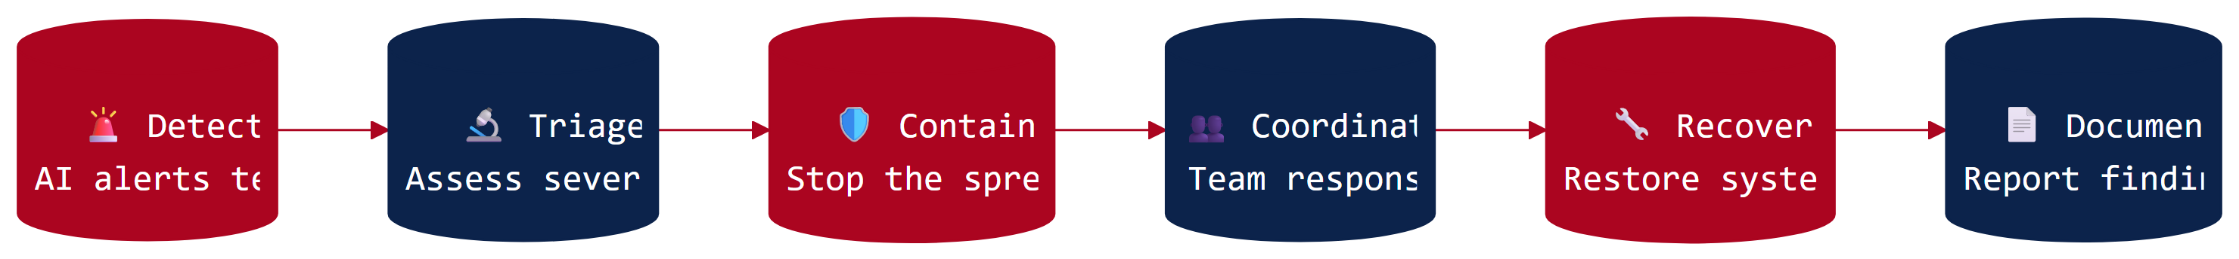

Grade-Band Versions

K-2: Fix It Team!
Duration: 20-25 minutes
Young students assume simple roles (Finder, Helper, Fixer, Talker) to solve a classroom technology problem, learning that teams with different jobs work together to address challenges.
View K-2 Version

Grades 3-5: Computer Problem Solvers
Duration: 35-40 minutes
Students form investigation teams with defined roles to respond to a school computer problem. They discover that different team members contribute different skills, with their AI partner serving as one member of the team.
View Grades 3-5 Version

Grades 6-8: AI-Assisted Incident Response
Duration: 50-60 minutes
Teams respond to realistic security incidents using NICE Framework-aligned roles. Multiple scenario options allow flexibility in complexity and focus areas.
View Grades 6-8 Version

Grades 9-12: SOC Analyst Simulation
Duration: 55-60 minutes
An enterprise-level breach scenario with technical depth. Students experience the pressure and coordination demands characteristic of Security Operations Center work during an active incident.
View Grades 9-12 Version

NICE Framework Alignment
Primary Work Roles: Incident Response, Defensive Cybersecurity, and Threat Analysis (Protection and Defense category)
Skills students practice: Incident triage, response coordination, automated threat detection integration, incident containment, and stakeholder communication
 Learn More: How Real SOCs Work
Security Operations Centers coordinate human analysts with AI-powered detection systems under intense time pressure—exactly what students experience in this activity. The NICE Framework defines these work roles precisely, and research on team-based cybersecurity learning shows that role-playing incident response builds lasting understanding of coordination dynamics.
Explore the research →

Supporting Materials
- Career Connections
- Quick-Start Guide
- Role Cards
- Incident Briefings
- Complication Cards
- AI Response Cards (for low-resource implementation):
  - Grades K-2: Sparky Cards
  - Grades 3-5: AI Helper Cards
  - Grades 6-8: AI Security Advisor Cards
  - Grades 9-12: SentinelAI Cards
- Assessment Rubrics

