Low-Resource Implementation Guide
  - Bringing Human-AI Partnership to Every Classroom
Table of contents

You Can Do This
The core learning outcome, understanding AI as a collaborative partner, does not require every student to have direct AI access. The framing matters more than the technology, and effective pedagogy can flourish regardless of your resource constraints.
This guide presents proven strategies for running True Teamwork activities in classrooms with limited or no direct AI access.

Strategy 1: Pre-Generated Response Cards
Best for: Classrooms with no live AI access available

How It Works
Before class, generate AI responses to common investigation questions. Print these as response cards organized by scenario and question type. During the activity, groups “consult AI” by drawing appropriate response cards. You can provide additional cards for unexpected questions that arise.

Response Card Categories
For Security Detective Teams, prepare cards covering password analysis observations, login pattern analysis, social engineering indicators, and investigation next steps.
For AI-Assisted Incident Response, create cards addressing technical threat assessment, containment recommendations, business impact analysis, and communication guidance.
For Ethics in Automated Security, develop cards presenting AI capability statements, AI limitation acknowledgments, policy trade-off analysis, and privacy considerations.

Sample Response Card
┌─────────────────────────────────────────┐
│ AI PARTNER RESPONSE │
│ Category: Password Analysis │
├─────────────────────────────────────────┤
│ "I notice these passwords follow │
│ predictable patterns - seasonal words, │
│ pet names, birthdays. An attacker │
│ could find this information on social │
│ media. However, I can't tell you WHY │
│ users chose these patterns or whether │
│ they received security training." │
│ │
│ MY LIMITATION: I analyze patterns, but │
│ humans understand context and culture. │
└─────────────────────────────────────────┘

Creating Your Own Cards
Use any AI to generate additional cards:
“Generate 5 AI response cards for a middle school cybersecurity activity about [topic]. Each response should show AI analysis AND acknowledge a limitation. Keep responses under 75 words.”

Strategy 2: Rotation Station
Best for: Classrooms with limited devices (1-3 devices for a class of 20-30)

How It Works
Set up an “AI Consultation Station” with available devices. Groups rotate through during the investigation phase while non-AI groups work on evidence analysis and documentation. A visible timer ensures fair access across all groups.

Rotation Schedule (45-minute activity)
Time | Station 1 (AI) | Station 2 (Evidence) | Station 3 (Documentation)
10-17 min | Groups A, B | Groups C, D | Groups E, F
17-24 min | Groups C, D | Groups E, F | Groups A, B
24-31 min | Groups E, F | Groups A, B | Groups C, D

Making Rotation Work
Have groups prepare questions before their AI station time arrives. Enforce strict time limits with a visible timer. Designate one “AI consultation lead” per group for efficiency, and have groups document AI responses immediately before rotating.

Strategy 3: Homework Preparation
Best for: Students who have home AI access but no access at school

How It Works
Students interact with AI at home on a preparation assignment, then bring their AI insights to class for collaborative work. Class time focuses on synthesis and decision-making rather than AI interaction.

Homework Assignment Example
Before Our Cybersecurity Investigation
- Open ChatGPT/Claude/Copilot at home
- Use this opening prompt: “You’re my cybersecurity partner. I’m preparing for an investigation activity. Help me understand what to look for in login logs.”
- Ask AI at least 3 follow-up questions
- Copy and paste your most useful AI response (or summarize in your own words)
- Write one thing AI helped you understand and one thing you’re still unsure about
Bring your notes to class tomorrow!

In-Class Integration
Groups share their homework findings and compare different AI responses, since students may have used different platforms. Class time then focuses on collaboration and synthesis rather than AI interaction.

Strategy 4: Think-Aloud Demonstration
Best for: Situations where one AI interaction serves the whole class

How It Works
The teacher conducts a single AI investigation visible to all students. Students observe and take notes, then discuss as a group. Individual or group work can follow on a parallel scenario without AI.

Making It Interactive
Pause frequently to ask students what question you should pose next. Let students vote on investigation directions. Allow student volunteers to dictate prompts while you type. This approach ensures everyone participates meaningfully even without individual devices.

Demonstration Script
“We’re going to watch me investigate with our AI partner. I want you to notice:
- How I frame questions as partnership, not just asking for answers
- When AI gives useful information
- When AI admits it doesn’t know something
- How I combine AI analysis with my own thinking
As you watch, think about what YOU would ask that I don’t.”

Hybrid Approaches
Different resource situations call for different combinations of strategies. Use this decision tree to find your recommended approach:

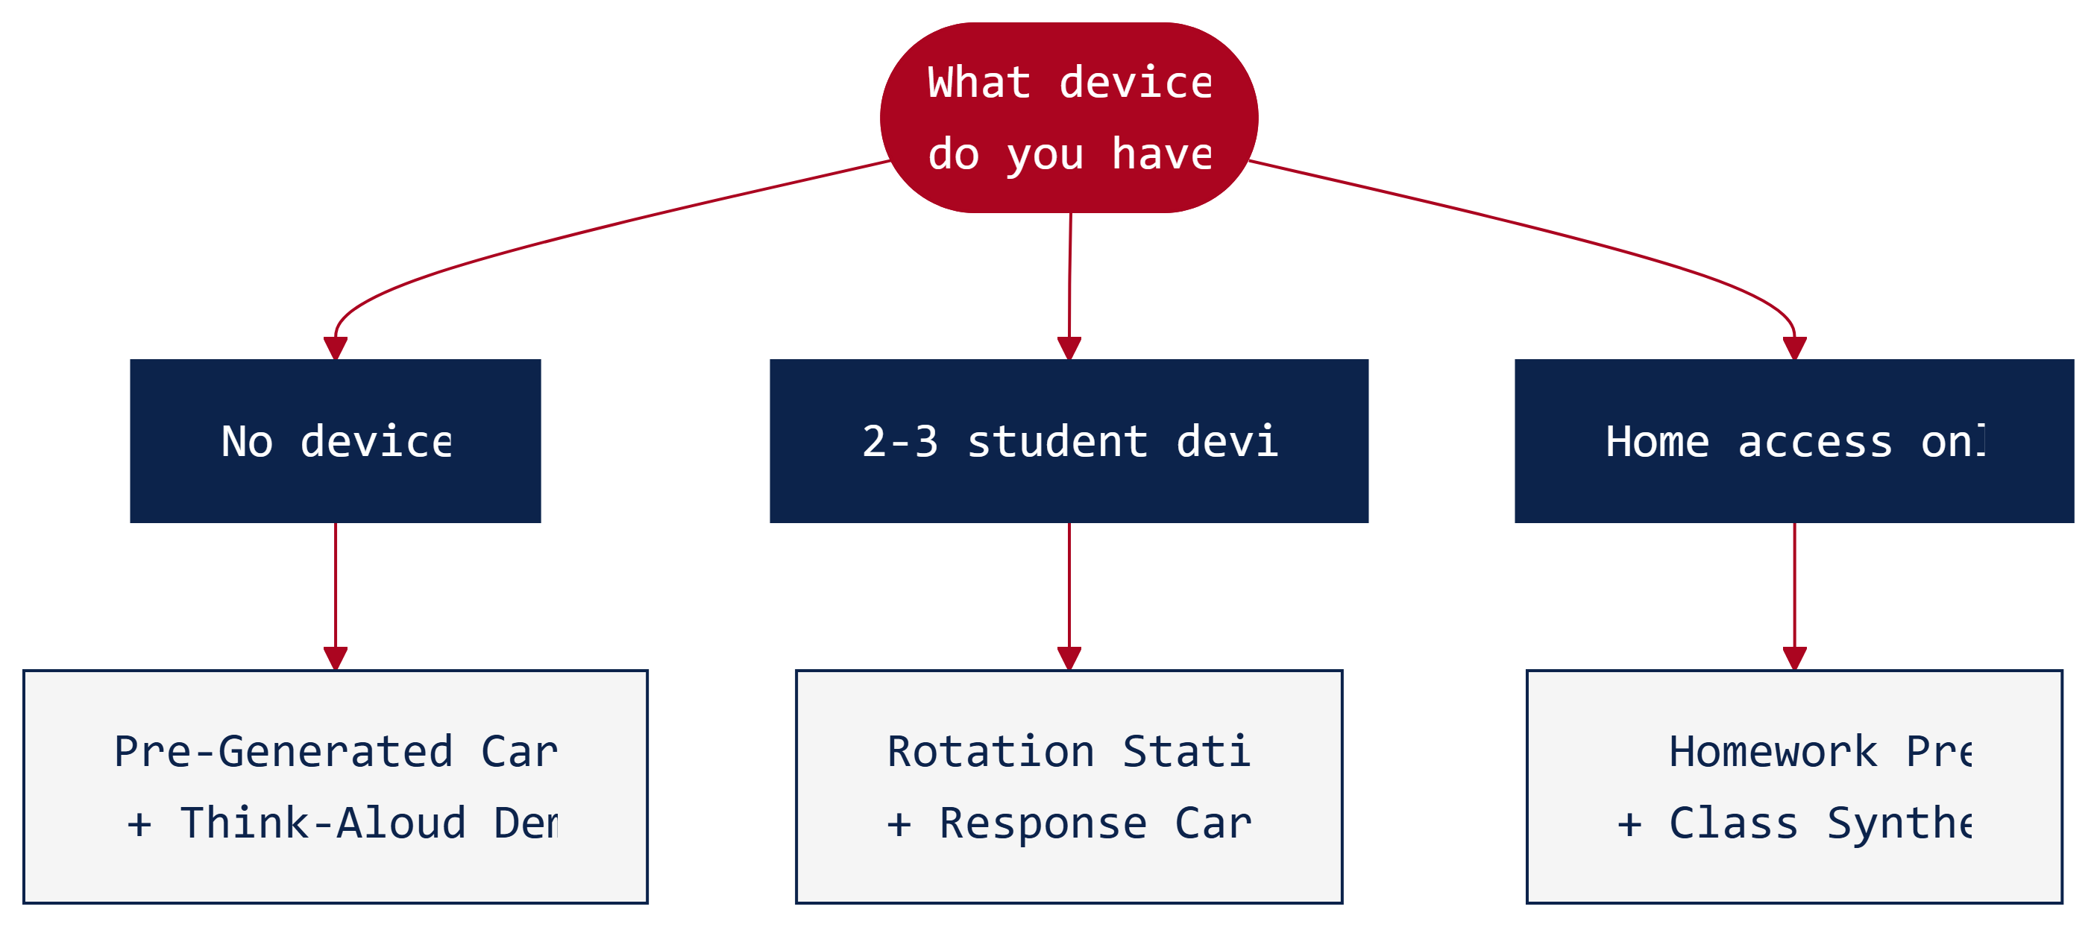

You Have | Recommended Approach
2-3 student devices | Rotation Station + Pre-Generated Cards
Some students have phones | Rotation + limited personal device use
Home access, no school access | Homework Preparation + Class Synthesis
No devices at all | Pre-Generated Response Cards + Think-Aloud Demo

Key Pedagogical Points

The Learning Happens Through Framing
Even without live AI, students develop essential understanding: that AI has specific capabilities alongside real limitations, that humans and AI contribute differently to problem-solving, that effective partnership requires knowing what each partner does well, and that final decisions require human judgment.

What Matters Most
The essential elements to preserve regardless of technology access include evidence analysis, team collaboration, decision justification, and career connection. Live AI interaction, multiple AI consultations, and individual AI access enhance the experience but are not essential to the core learning outcomes.

Low-Resource Can Be High-Quality
Low-resource approaches offer distinct advantages. They create more time for human discussion, encourage deeper analysis by preventing surface-level AI queries, develop better documentation practices, strengthen peer collaboration, and allow teachers to model excellent AI interaction.
 Learn More: Equity in AI Education
Research on AI in education emphasizes that learning outcomes depend more on pedagogical framing than technology access. Students who deeply understand human-AI partnership dynamics through well-designed low-resource activities often outperform those with constant AI access but shallow engagement. The goal is understanding, not interaction counts.
Explore the research →

Troubleshooting
Challenge | Solution
Students frustrated without AI access | Frame as “real-world constraint”—not every SOC has latest tools
Pre-generated responses feel fake | Update cards based on student questions; add variety
Rotation takes too long | Reduce AI station time; emphasize preparation
Homework access unequal | Make it optional enrichment; pair haves/have-nots
Activity feels different without AI | Focus on human collaboration; AI is one team member

Adapting Specific Activities

Security Detective Teams (Low-Resource)
For this activity, pre-generate password analysis cards and have the teacher demonstrate one investigation path. Groups focus on human evidence analysis while sharing a common set of AI observations across all groups.
Ready-to-use printables for this activity include an Evidence Packet containing core investigation documents, grade-differentiated AI Response Cards with pre-generated AI analysis, and Student Worksheets providing structured investigation recording. Four grade-band-specific AI Response Card sets are available:
Grade Band | Card Set | AI Voice
K-2 | Robot Helper Cards | Friendly, simple (“Beep boop!”)
3-5 | Computer Helper Cards | Approachable, slightly technical
6-8 | AI Partner Cards | Collaborative peer voice
9-12 | AI Security Analyst Cards | Professional SOC analyst language
Each card set follows the same pedagogical pattern: AI demonstrates capability, AI acknowledges limitation, human judgment required. These materials are available in the printables directory.

AI-Assisted Incident Response (Low-Resource)
For this activity, pre-generate threat assessment and recommendation cards. Groups draw cards at decision points, with emphasis on role-playing and team coordination. AI responses reveal gradually, functioning like game cards that add information as the activity progresses.
Ready-to-use printables for this activity include Incident Briefings with scenario cards for each incident type, AI Response Cards containing threat analysis and recommendations, Role Cards defining team responsibilities, and Complication Cards introducing mid-activity escalations. Four grade-band-specific AI Response Card sets are available:
Grade Band | Card Set | AI Voice
K-2 | Sparky Robot Helper Cards | Friendly, encouraging (“Beep boop!”)
3-5 | AI Helper Cards | Approachable, pattern-focused
6-8 | AI Security Advisor Cards | Collaborative analyst voice
9-12 | SentinelAI SOAR Platform Cards | Enterprise SOC with MITRE ATT&CK mapping
Each card set aligns with the grade-specific incident scenarios (Fix It Team, Computer Problem Solvers, School Incidents, Enterprise SOC). These materials are available in the printables directory.

Ethics in Automated Security (Low-Resource)
This activity works particularly well without live AI because it centers on discussion. Use the printed AI Perspective Cards already included in the activity materials, with the teacher reading AI perspectives aloud. Students can argue for the AI position as a role-play exercise.
Ready-to-use printables for this activity include AI Perspective Cards providing AI voice statements for each policy question, Policy Scenario Cards with discussion prompts, and Stakeholder Cards offering role perspectives for debate. Four grade-band-specific AI Perspective Card sets are available:
Grade Band | Card Set | AI Voice
K-2 | Sparky Robot Helper Cards | Simple, curious (“I wonder why…”)
3-5 | SchoolGuard Cards | Helpful, questioning about rules
6-8 | SchoolGuard Cards | Detailed governance perspectives
9-12 | SecureNet AI Cards | Enterprise policy with FERPA/COPPA context
Each card set presents the AI’s perspective on policy decisions appropriate to the grade-band scenario (Robot Helper Rules, Computer Rules Committee, SchoolGuard Governance, Enterprise Security Policy). These materials are available in the printables directory.

Grade-Band Implementation Guidance
Different strategies work better for different age groups. The following table summarizes recommended approaches based on developmental appropriateness:
Grade Band | Recommended Primary Strategy | Why It Works
K-2 | Pre-Generated Cards + Think-Aloud Demo | Concrete materials support emerging readers while teacher demonstration models partnership thinking
3-5 | Pre-Generated Cards + Think-Aloud Demo | Concrete materials support developing readers while teacher modeling demonstrates partnership
6-8 | Rotation Station | Developing independence, peer learning during wait time, and structured transitions
9-12 | Homework Prep + Class Synthesis | Students can manage independent AI interaction, and class time maximizes higher-order discussion

 Quick Decision Guide
Use the following recommendations based on your available resources:
If you have no devices at all, use Pre-Generated Response Cards combined with Think-Aloud Demonstration.
If you have a few student devices, use the Rotation Station approach with structured timing.
If students have home access but not school access, use Homework Preparation combined with Class Synthesis.

Remember
The goal is not for every student to interact directly with AI. The goal is for every student to understand human-AI partnership in cybersecurity.
Creative pedagogy achieves that goal effectively, even without the latest technology.
True Teamwork: Building Human-AI Partnerships for Tomorrow’s Cyber Challenges, NICE K12 2025

